**SOUTHWEST FLORIDA WATER**

**MANAGEMENT DISTRICT**

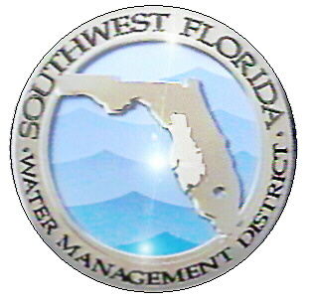

“Collect and Analyze Data to Determine Local and Regional Water Quality Status and Trends” Metric:

How to Compile, Analyze and Present

|  |  |  |  |
| --- | --- | --- | --- |
| **Revision Chronology** | | **Review Date** |  |
| **Assigned Reviewer** |  |
| **Document ID** | **Effective Date** | **Reason for Change** | |
| V.1 |  |  | |
| V.2 |  |  | |
|  |  |  | |
|  |  |  | |
|  |  |  | |

Table of Contents

Purpose 1

Metric 1

How to Assemble the Data 2

How to Analyze the Data 2

How to Present the Data 4

Appendix 1

# Purpose

The purpose of this document is to provide instruction on how to compile, analyze and present metrics in support of the District’s Strategic Plan or Business Plan. The details provided will ensure consistent generation and storage of this information for use in future metrics updates.

# Metric

# *Description*: The District’s Strategic Plan for 2014 – 2018 established a “Water Quality Assessment and Planning Goal” to collect and analyze data to determine local and regional water quality status and trends to support resource management decisions and restoration initiatives. The metric will apply to the District’s (non-spring) SWIM Priority Waterbodies and Regionally Significant Lakes.

# **District’s Estuarine SWIM Priority Waterbodies (Tampa and Sarasota Bay and Charlotte Harbor)**

# The metric will be based on bay-wide seagrass coverage data collected every two years by the District. All data will be evaluated against seagrass coverage goals (in acres) adopted by the Estuary Programs for the waterbodies. Waterbodies and the seagrass goals are listed in the Appendix.

**District’s SWIM Priority Lakes and Regionally Significant Lakes**

The metric will assemble water quality data stored in the District’s Water Management Information Systems database (WMIS) and the Florida Department of Protection’s (FDEP) Impaired Waters Rule (IWR) database on an annual basis for the District’s SWIM Priority Lakes and Regionally Significant lakes identified in the District’s Strategic Plan.

**SWIM Priority Lakes**

The SWIM Priority Lakes include: Lake Panasoffkee, Lake Tarpon, Lake Thonotosassa and the Winter Haven Chain of Lakes.

There are two possible sources of metrics for the SWIM Lakes within the District. These include: 1) Numeric Nutrient Criteria (NNC) found in Chapter 62-302.531 Numeric Interpretations of Narrative Nutrient Criteria, Florida Statutes or; 2) adopted Total Maximum Daily Loads. The source of the metric for each waterbody is discussed in the Appendix.

**Regionally Significant Lakes**

**Lake Seminole -** The metric for Lake Seminole is from the Lake Seminole Reasonable Assurance Plan developed by Pinellas County and submitted to FDEP in 2007.

**Ridge Lakes** - There are approximately 130 lakes that lie along the 90-mile Lake Wales Ridge (Ridge), which extends from the cities of Davenport and Haines City (Polk County) in the north to Sebring and Lake Placid (Highlands County) to the south.

Polk County conducts routine water quality monitoring on the lakes in Polk County which have public access. The lakes are sampled quarterly each year for standard water quality parameters including those needed to compare a lake’s status to Numeric Nutrient Criteria established by FDEP. At this time the sampling frequency for the lakes in Highlands County is not known.

Due to the number of lakes in the Ridge, the metric for this system is the development of a planning document to identify data availability for the lakes, and determine if sentinel lakes can be selected for monitoring that would represent lakes within each region of the Ridge.

*Required Output:* For all lakes except the Ridge lakes, the metric result will represent the status of water quality relative to the target (in compliance with the target, deteriorated condition compared to the target or improved condition relative to the target) and whether there is an improving or deteriorating trend in water quality.

*Frequency of Reporting*: Metric results will be compiled and reported every two years for the estuarine systems. Metric results will be compiled and reported on an annual basis for the lakes.

*Responsible Party*: SWIM, WQMP and ITB staff will extract, compile and report the results on this metric.

# How to Assemble the Data

Estuaries

*Where are the data stored and retrieved*: Seagrass data are collected by the District and stored in the District’s GIS files as a map layer.

Step 1. Acquire data on seagrass coverage from biennial seagrass mapping for Tampa and Sarasota Bays and Charlotte Harbor. Imagery source data is collected in the winter (December through February). Guidelines for accuracy and acceptance of the GIS data deliverable from the contractor are included in the scope of work with the contractor and may change due to technology advances or other reasons. Once the GIS data deliverables are accepted by the District, the seagrass distribution is analyzed by waterbody specific reporting units called bay segments.  Distribution data are reviewed spatially to locate areas of importance that experienced significant gains or losses.  The acreage estimates are also plotted in time series graphs to demonstrate changes over the period of record.

The map products derived from imagery take approximately one year to produce and the GIS maps are available in March of the following year. For example imagery was collected December 2015 through February 2016 and the map product is scheduled to be available March 2017.

Step 2. Using GIS and the seagrass map data, calculate the bay-wide seagrass coverage in acres for each estuarine waterbody.

Lakes

*Where are the data stored and retrieved*: Data for actively monitored lakes are stored in the District’s WMIS and the FDEP IWR Database.

1. Lakes evaluated using FDEP Numeric Nutrient Criteria (NNC)

The information below was summarized from Chapter 62-302.531 Numeric Interpretations of Narrative Nutrient Criteria, Florida Statutes.

Step1. *Classify the Lake Based on Period of Record Data.* On June 30, query and acquire period of record data for color and alkalinity for each lake. The instructions for querying and acquiring the data are included in the Appendix.

Each lake must be classified as a low color (color ≤ 40 PCU) or high color (color > 40 PCU) lake. Low color lakes are further classified as acidic (alkalinity ≤ 20 mg/L) or alkaline (alkalinity > 20 mg/L).

Color is assessed as true color and is to be free from turbidity. Lake color and alkalinity are to be calculated as the long-term geometric mean of all of the data for the period of record, based on a minimum of ten data points over at least three years with at least one data point in each year. Rule 62-600.200(33), F.A.C., defines “Geometric mean” as the nth root of the product of n numbers. In other words, in order to calculate the geometric mean of n observations, each of the n values would be multiplied together and the resulting product will be raised to the 1/nth power. The geometric mean should be computed using the monthly values for nth year. The method for calculating the geometric mean using R is included in the Appendix.

If insufficient alkalinity data are available, long-term geometric mean specific conductance values of all of the data for the period of record shall be used, with a value of <100 micromhos/cm used to estimate the 20 mg/L CaCO3 alkalinity concentration until such time that alkalinity data are available. Long-term geometric mean specific conductance shall be based on a minimum of ten data points over at least three years with at least one data point in each year.

Step 2. *Assign the applicable NNC to each lake based on its classification using the table below.* The minimum or maximum criteria are assigned based on the annual geometric chlorophyll-a concentration for the 12 month period preceding the assessment.

Table 1. Lake NNC chlorophyll-a, total nitrogen and total phosphorus.

|  |  |  |  |  |  |
| --- | --- | --- | --- | --- | --- |
| Long Term Geometric Mean Lake Color and Alkalinity | Annual Geometric Mean Chlorophyll *a* | Minimum calculated numeric interpretation | | Maximum calculated numeric interpretation | |
| Annual Geometric Mean Total  Phosphorus | Annual Geometric Mean Total  Nitrogen | Annual Geometric Mean Total  Phosphorus | Annual Geometric Mean Total  Nitrogen |
| > 40 Platinum Cobalt Units | 20 µg/L | 0.05 mg/L | 1.27 mg/L | 0.16 mg/L1 | 2.23 mg/L |
| ≤ 40 Platinum Cobalt Units and > 20 mg/L CaCO3 | 20 µg/L | 0.03 mg/L | 1.05 mg/L | 0.09 mg/L | 1.91 mg/L |
| ≤ 40 Platinum Cobalt Units and ≤ 20 mg/L CaCO3 | 6 µg/L | 0.01 mg/L | 0.51 mg/L | 0.03 mg/L | 0.93 mg/L |

1 For lakes with color > 40 PCU in the West Central Nutrient Watershed Region, the maximum TP limit shall be the 0.49 mg/L TP streams threshold for the region.

Step 3. On June 30, query and acquire data for total nitrogen, total phosphorus and chlorophyll-a for the previous 12 month period for each waterbody. Calculate the annual geometric mean for each of the parameters for each lake. A minimum of four temporally independent sampling events are required in a calendar year to calculate the annual geometric mean, with at least one occurring during the period from May to September and October to April.

1. Lakes with an Adopted Reasonable Assurance (RA) Plan

Step 1. On June 30, query and acquire the target data identified in the Adopted RA Plan for the previous 12-month period for each waterbody.

Step 2. Calculate the annual geometric mean for each of the target parameters. A minimum of four temporally independent sampling events are required in a calendar year to calculate the annual geometric mean, with at least one occurring during the period from May to September and October to April.

1. Lakes with an Adopted Total Maximum Daily Load

Step1. *Classify the Lake based on Period of Record Data.* On June 30, query and acquire period of record data for color and alkalinity for each lake.

Each lake must be classified as a low color (color ≤ 40 PCU) or high color (color > 40 PCU) lake. Low color lakes are further classified as acidic (alkalinity ≤ 20 mg/L) or alkaline (alkalinity > 20 mg/L).

Color is assessed as true color and is to be free from turbidity. Lake color and alkalinity are to be calculated as the long-term geometric mean of all of the data for the period of record, based on a minimum of ten data points over at least three years with at least one data point in each year. If insufficient alkalinity data are available, long-term geometric mean specific conductance values of all of the data for the period of record shall be used, with a value of <100 micromhos/cm used to estimate the 20 mg/L CaCO3 alkalinity concentration until such time that alkalinity data are available. Long-term geometric mean specific conductance shall be based on a minimum of ten data points over at least three years with at least one data point in each year.

Step 2. *Determine the applicable chlorophyll-a criterion based on the color and alkalinity of the lake.*

Step 3. On June 30, query and acquire data for chlorophyll-a for the previous 12 month period for each lake with a TMDL. Calculate the annual geometric mean for chlorophyll- a for each lake. A minimum of four temporally independent sampling events are required in a calendar year to calculate the annual geometric mean, with at least one occurring during the period from May to September and October to April.

# How to Analyze the Data

Estuaries

Step 1. Compare the bay-wide seagrass acreage to the goals for seagrass established by the Tampa and Sarasota Bay Estuary Programs and the Charlotte Harbor National Estuary Program.

Step 2. Prepare bar graphs showing the seagrass acreage relative to the goals for the period of record.

STATUS

1. Lakes evaluated using FDEP Numeric Nutrient Criteria (NNC)

Step 1. Determine the lake classification (colored lake or non-colored lake) and compare the annual geometric mean of the chlorophyll-a concentration to the chlorophyll-a value for the type of lake (Table1).

The minimum or maximum nutrient criteria are assigned based on the annual geometric mean of the chlorophyll-a concentration for a given year. For example, if the annual geometric chlorophyll-a concentration exceeds 20 µg/L for a colored lake, the TP ad TN criteria are 0.05 and 1.27 mg/l for that year respectively. However if the chlorophyll-a concentration is below 20 µg/L criterion, the TP and TN criteria are 0.16 and 2.23 mg/L, respectively. The criteria are compared to the annual geometric mean of each parameter. More than one exceedance in any three year period is indicative of an impaired waterbody.

1. Lakes with an Adopted Reasonable Assurance Plan

Step 1. Compare the annual geometric mean for the target parameters and determine if the current annual geometric mean is above or below the target(s) identified in the RA Plan.

1. Lakes with an Adopted Total Maximum Daily Load

Step 1. Determine the lake classification (colored lake or non-colored lake) and compare the annual geometric mean for the chlorophyll-*a* to the applicable chlorophyll-a criterion and determine if the current annual geometric mean is above or below the chlorophyll-a criterion for a colored or non-colored lake.

TRENDS

Step 1. Calculate the chlorophyll-a trend using the “Kendall” package in R. The Kendall package has a function MannKendall. This is a test for monotonic trend in a time series based on the Kendall rank correlation. It will conduct a statistical analysis to determine the trend that data have over a period of time.

Step 2. Plot the annual geometric mean for chlorophyll-a for the period of record against the chlorophyll-a target for the lake based on the color classification described in Table 1.

# How to Present the Data

Estuaries

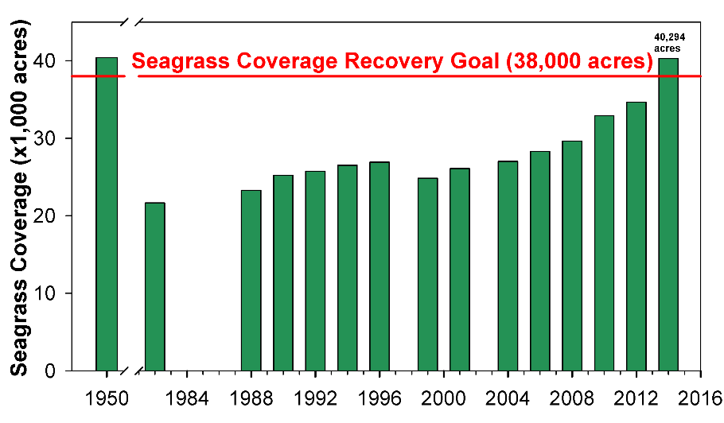Estuarine data will be presented in bar graphs to show whether the estuary is meeting its seagrass goals.

Lakes

Lakes data will be presented annually in tables to show whether the waterbody is meeting its water quality target and to show the long term trend in water quality.

|  |  |  |  |  |
| --- | --- | --- | --- | --- |
| Waterbody | Current Annual Geometric Mean Chlorophyll a (ug/L) | Target Geometric Mean Chlorophyll a (ug/L) | Status | Trend |
| Lake Woebegone | 18 | 20 | Below target |  |
| Lake Gator | 18 | 20 | Below target |  |
| Lake Nonole | 25 | 20 | Above Target |  |

# References

# Appendix

**Estuarine Seagrass Goals**

**Tampa Bay**

The bay-wide seagrass target adopted by the Tampa Bay Estuary Program is 38,000 acres.

**Sarasota Bay**

The bay-wide seagrass target adopted by the Sarasota Bay Estuary Program is 9,797 acres.

**Charlotte Harbor**

The harbor-wide seagrass target adopted by the Charlotte Harbor National Estuary Program is 18,436 acres and encompasses only the portion of the Harbor in the Southwest Florida Water Management District.

**Freshwater Lakes**

**Targets**

For the majority of SWIM Priority water body lakes and the lakes of regional significance within the Southwest Florida Water Management District, the water quality targets have been set to be consistent with Numeric Nutrient Criteria for Lakes as described in paragraph 62-302.530(47)(b), F.A.C. or they have been set to targets established by an adopted Total Maximum Daily Load or an adopted Reasonable Assurance Plan.

**From 62-302.531 Numeric Interpretations of Narrative Nutrient Criteria**

1. For lakes, the applicable numeric interpretations of the narrative nutrient criterion in paragraph 62-302.530(47)(b), F.A.C., for chlorophyll a are shown in the table below. The applicable interpretations for TN and TP will vary on an annual basis, depending on the availability of chlorophyll a data and the concentrations of nutrients and chlorophyll a in the lake, as described below. The applicable numeric interpretations for TN, TP, and chlorophyll a shall not be exceeded more than once in any consecutive three year period.

a. If there are sufficient data to calculate the annual geometric mean chlorophyll a and the mean does not exceed the chlorophyll a value for the lake type in the table below, then the TN and TP numeric interpretations for that calendar year shall be the annual geometric means of lake TN and TP samples, subject to the minimum and maximum limits in the table below. However, for lakes with color > 40 PCU in the West Central Nutrient Watershed Region, the maximum TP limit shall be the 0.49 mg/L TP streams threshold for the region; or

b. If there are insufficient data to calculate the annual geometric mean chlorophyll a for a given year or the annual geometric mean chlorophyll a exceeds the values in the table below for the lake type, then the applicable numeric interpretations for TN and TP shall be the minimum values in the table below.

|  |  |  |  |  |  |
| --- | --- | --- | --- | --- | --- |
| Long Term Geometric Mean Lake Color and Alkalinity | Annual Geometric Mean Chlorophyll *a* | Minimum calculated numeric interpretation | | Maximum calculated numeric interpretation | |
| Annual Geometric Mean Total  Phosphorus | Annual Geometric Mean Total  Nitrogen | Annual Geometric Mean Total  Phosphorus | Annual Geometric Mean Total  Nitrogen |
| > 40 Platinum Cobalt Units | 20 µg/L | 0.05 mg/L | 1.27 mg/L | 0.16 mg/L1 | 2.23 mg/L |
| ≤ 40 Platinum Cobalt Units and > 20 mg/L CaCO3 | 20 µg/L | 0.03 mg/L | 1.05 mg/L | 0.09 mg/L | 1.91 mg/L |
| ≤ 40 Platinum Cobalt Units and ≤ 20 mg/L CaCO3 | 6 µg/L | 0.01 mg/L | 0.51 mg/L | 0.03 mg/L | 0.93 mg/L |

1 For lakes with color > 40 PCU in the West Central Nutrient Watershed Region, the maximum TP limit shall be the 0.49 mg/L TP streams threshold for the region.

c. For the purpose of subparagraph 62-302.531(2)(b)1., F.A.C., color shall be assessed as true color and shall be free from turbidity. Lake color and alkalinity shall be the long-term geometric mean, based on a minimum of ten data points over at least three years with at least one data point in each year. If insufficient alkalinity data are available, long-term geometric mean specific conductance values shall be used, with a value of <100 micromhos/cm used to estimate the 20 mg/L CaCO3 alkalinity concentration until such time that alkalinity data are available.

An exception to this method occurs when a Reasonable Assurance Plan or Total Maximum Daily Load has been adopted for the waterbody. These exceptions and their applicable targets are listed below. If the lake is not listed as an exception, then the FDEP Numeric Nutrient Criteria apply.

**Data Availability and metric if Different from NNC**

**Lake Panasoffkee**

Lake Panasoffkee is a District SWIM Priority Waterbody located in Sumter County. The District monitors Lake Panasoffkee on quarterly basis for a variety of water quality parameters including those needed to assess the lake against the numeric nutrient criteria.

**Lake Thonotosassa**

Lake Thonotosassa is a District SWIM Priority Waterbody located in Hillsborough County. Hillsborough County routinely monitors Lake Thonotosassa for a variety of water quality parameters including those needed to assess the lake against the targets listed below.

Chlorophyll-a ≤ 20 µg/L

Total Phosphorus ≤ 0.49 mg/L

Total Nitrogen ≤ 1.2 mg/L per EPA TMDL

**Lake Tarpon**

Lake Tarpon is a District SWIM Priority Waterbody located in Pinellas County. Pinellas County routinely monitors Lake Tarpon for a variety of water quality parameters. Lake Tarpon is a highly colored lake and will be tracked using NNC for lakes.

**Lake Seminole**

Lake Seminole has been identified as a waterbody of regional significance by the Southwest Florida Water Management District. The Lake is currently listed as an impaired waterbody pursuant to Section 303(d) of the federal Clean Water Act. In 2007, Pinellas County developed a Reasonable Assurance Plan which was submitted to the Florida Department of Environmental Protection.

The Lake Seminole RA Plan established the water quality goals for the Lake. The Lake Seminole RA plan water quality goals are expressed as annual means for chlorophyll-a and the Trophic State Index (TSI). The targets are:

Chlorophyll-a ≤ 30 µg/L

TSI ≤ 60.

**Winter Haven Chain of Lakes**

The Winter Haven Chain of Lakes is a SWIM Priority Waterbody and includes 25 lakes. Several lakes have TMDL’s set by FDEP as noted in the table below (Chapter 62-304.635 Peace River Basin TMDLs). If there is not a TMDL listed for the lake, then the FDEP NNC for lakes will apply.

Polk County routinely monitors all the lakes in the Winter Haven Chain of Lakes, with the exception of Lake Henry which has no public access. The lakes are sampled quarterly each year for standard water quality parameters including those needed to compare a lake’s status to Numeric Nutrient Criteria established by FDEP.

|  |  |  |  |  |  |
| --- | --- | --- | --- | --- | --- |
| **Lake** | **TP** | **TN** | **Chl-a** | **TMDL** | **Sampled By Polk County** |
| Blue |  |  |  |  | Y |
| Cannon | 143 kg/yr |  | 20 µg/L | Y | Y |
| Conine |  |  |  |  | Y |
| Eloise |  |  |  |  | Y |
| Fannie |  |  |  |  | Y |
| Haines |  |  |  |  | Y |
| Hamilton |  |  |  |  | Y |
| Hartridge |  |  |  |  | Y |
| Henry |  |  |  |  | N |
| Howard | 143 kg/yr |  | 20 µg/L | Y | Y |
| Idylwild | 64 kg/yr | 1.05-1.91 mg/L depending on AGME Chl-a | 20 µg/L | Y | Y |
| Jessie | 140kg/yr | 1.05-1.91 mg/L depending on AGME Chl-a | 20 µg/L | Y | Y |
| Little Hamilton |  |  |  |  | Y |
| Lulu | 84 kg/yr | 1.05-1.91 mg/L depending on AGME Chl-a | 20 µg/L | Y | Y |
| Mariana |  |  |  |  | Y |
| May | 88 kg/yr | 1.05-1.91 mg/L depending on AGME Chl-a | 20 µg/L | Y | Y |
| Middle Hamilton |  |  |  |  | Y |
| Mirror | 55 kg/yr |  | 20 µg/L | Y | Y |
| Rochelle |  |  |  |  | Y |
| Roy |  |  |  |  | Y |
| Shipp | 97 kg/yr |  | 20 µg/L | Y | Y |
| Smart |  |  |  |  | Y |
| Spring |  |  |  |  | Y |
| Summit |  |  |  |  | Y |
| Winterset |  |  |  |  | Y |

**Method to Download Data from WMIS**

The District’s water quality monitoring network data are available on-line via the Water Management Information System (WMIS). ArcGIS can be used as a complement to WMIS to determine if the District have data collection sites in the area of interest. If there is are no points on the map for the area of interest, then there are no data available from the District’s monitoring networks for that waterbody. The WMIS map interface and downloading of data can be located by going to:

• [Resource Data Search](http://bkvvmwmis03p/ResData/Search/Default.aspx), this should be opened in Chrome.

* Hover over “Menu” in the top left corner of the screen.
  + Scroll down to “Maps”
  + Select “View Map”
* When the map loads navigate to the left side of the webpage, where it says “Map Contents”
  + Select “Resource Data Collection Sites”, as well as any other layers of interest this loads in the points to allow you to interact with them in the ArcGIS viewer.
* Once you locate an area of interest select the point by clicking on it.
* If data is available a screen will pop up providing information regarding the site
  + Scroll down to “RD_SITES_WMIS_URL
  + Click “link”, this should open up a new web browser tab or window
* On the new window that opens you should see a list of tabs along the top, click on Site Data
* In the Site Data tab you have the choice to select a date range or receive all data. Select the parameters for the analyses
  + Click “Download Data” once the desired date range and parameters are selected
* In the new window that appears called “Site Download”. Select the sites to be downloaded and the parameters you wish to be downloaded.
* Then click “Submit Download Request”
  + If done properly you should receive an email shortly with the requested data.

**Method to Download Data from the FDEP IWR Database**

To access the FDEP IWR Database navigate to:

[**http://www.dep.state.fl.us/water/watersheds/assessment/index.htm**](http://www.dep.state.fl.us/water/watersheds/assessment/index.htm)

Once there, click on the IWR runs link. <http://publicfiles.dep.state.fl.us/dear/IWR/>

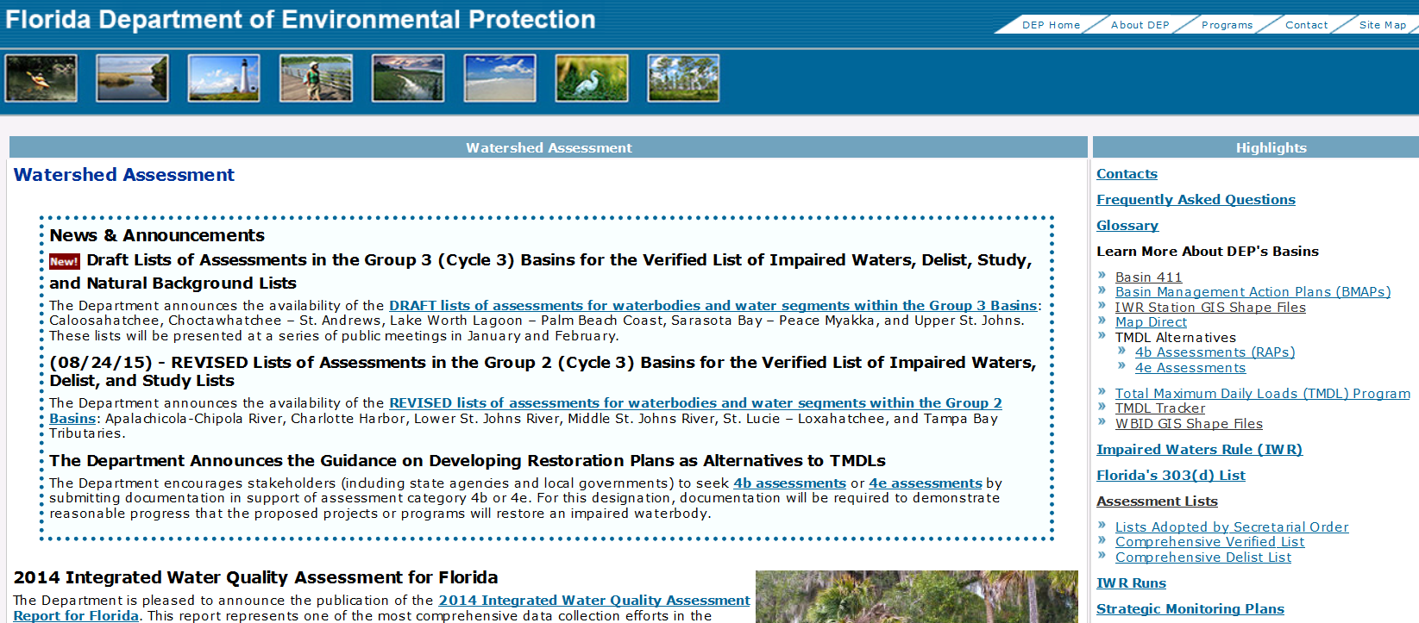

Download the most recent IWR Run Zip File

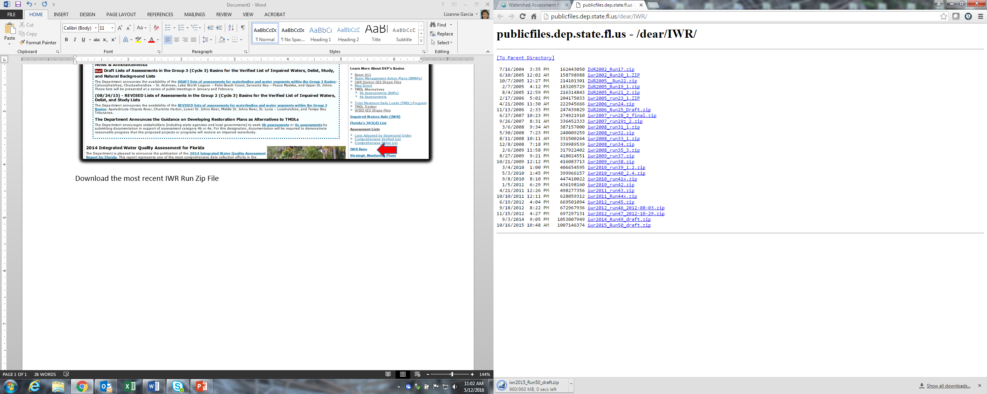

Unzip the files to your PC. Open the ReadMe file and follow the instructions to get to the IWR Retrieval tool. Navigate to the Report Card for Individual Waterbodies.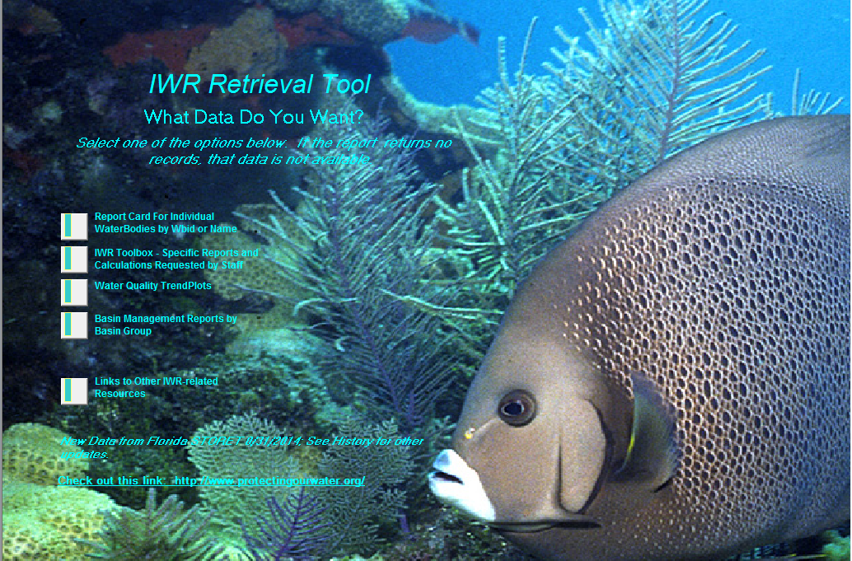

On this page, enter the waterbody name (For Example Lake Thonotosassa), then Follow Step 2. In Step 3 select the IWR Data for the entire period of Record. Download the data in Step 4. If the report returns no data, no data are available for that waterbody.

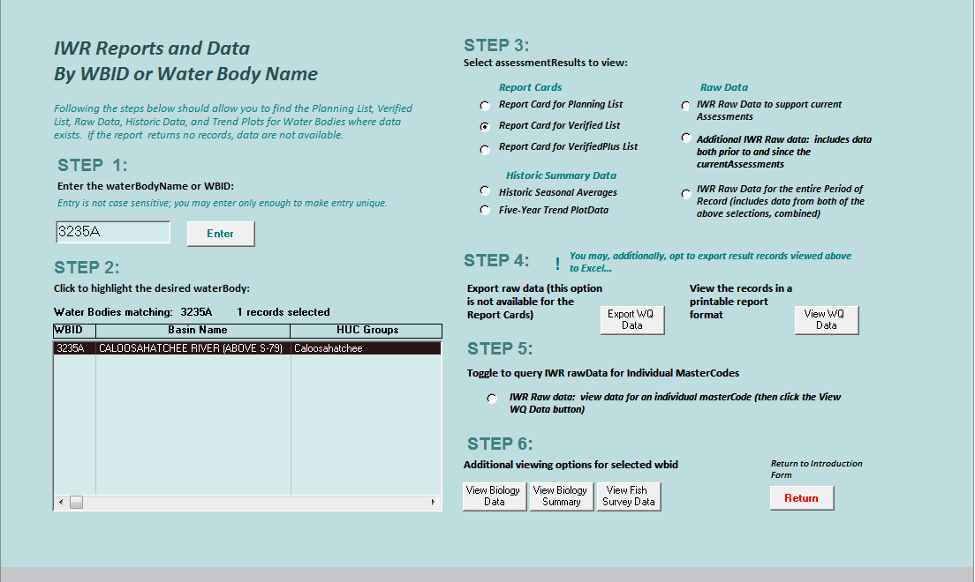

For assistance with downloading data from FDEP IWR database, contact Kevin O’Donnell, [Kevin.Odonnell@dep.state.fl.us](mailto:Kevin.Odonnell@dep.state.fl.us) or at 850.245.8469.

**Example of Geometric Mean Calculation in R**

###Geometric Mean Calculation###

> ## Compute geometric mean

> prod(G)^(1/n) # multiplies each number in G, the product is then rooted to n

[1] 4.528729

> ## Create vector of numbers

> G <- c(10,9,8,7,6,5,4,3,2,1)

>

> ## Find length of G

> n <- length(G) # n now equals the number of elements in G

>

> ## Compute geometric mean

> prod(G)^(1/n) # multiplies each number in G, the product is then rooted to n

[1] 4.528729

**Example of Mann-Kendall Analysis in R**

> ## Create time-series class to run Mann-Kendall Analysis

> DateField <- as.Date(c("2000-01-01","2001-01-01","2002-01-01","2003-01-01","2004-01-01","2005-01-01","2006-01-01","2007-01-01","2008-01-01",

+ "2009-01-01", "2010-01-01", "2011-01-01","2012-01-01","2013-01-01","2014-01-01","2015-01-01"))

> format(DateField, format="%Y-%m-%d")

[1] "2000-01-01" "2001-01-01" "2002-01-01" "2003-01-01" "2004-01-01" "2005-01-01" "2006-01-01" "2007-01-01" "2008-01-01"

[10] "2009-01-01" "2010-01-01" "2011-01-01" "2012-01-01" "2013-01-01" "2014-01-01" "2015-01-01"

>

>

> Result <- c(0.68, 0.17, 0.29, 0.91, 0.85, 0.89, 0.68, 0.72, 0.49, 0.18, 0.26, 0.30, 0.76, 0.12, 0.23, 0.04)

>

> DataFrame <- data.frame(DateField,Result)

> CreatedXTS <- xts(DataFrame$Result, DataFrame$DateField)

>

> ##Run MannKendall function while saving the results

> MK_Results <- MannKendall(CreatedXTS)

> MK_Results

tau = -0.36, 2-sided pvalue =0.058376